Movie File Merger User Manual



Work in progress, but still better than nothing...

# Warranty

THERE IS NO WARRANTY FOR THE PROGRAM AND/OR DOCUMENTATION, TO THE EXTENT PERMITTED BY APPLICABLE LAW. EXCEPT WHEN OTHERWISE STATED IN WRITING THE COPYRIGHT HOLDERS AND/OR OTHER PARTIES PROVIDE THE PROGRAM AND/OR DOCUMENTATION “AS IS” WITHOUT WARRANTY OF ANY KIND, EITHER EXPRESSED OR IMPLIED, INCLUDING, BUT NOT LIMITED TO, THE IMPLIED WARRANTIES OF MERCHANTABILITY AND FITNESS FOR A PARTICULAR PURPOSE. THE ENTIRE RISK AS TO THE QUALITY AND PERFORMANCE OF THE PROGRAM AND/OR DOCUMENTATION IS WITH YOU. SHOULD THE PROGRAM PROVE DEFECTIVE AND/OR THE DOCUMENTATION PROVE WRONG, YOU ASSUME THE COST OF ALL NECESSARY SERVICING, REPAIR OR CORRECTION.

# Table of Contents

Warranty 2

Table of Contents 3

Introduction 5

MFM Usage 6

Basic Steps 6

Select the Collection Type 7

Use the Drop Areas 7

Export List 7

Search Torrentz 7

Erase Color 8

Erase Selected 8

Search IMDb 8

Play Video 8

Media Info – ALL Check Box 8

Use the Lists 8

Garbage List 9

Existing List 10

Wish List 10

Import List 10

MFM and Dropbox 10

MFM and GOM 12

MFM and IMDb 13

Set the Folders 14

Target Folder 14

Import Folder 15

Process the Import 15

Copy 15

Move 15

Keep Folders 15

Progress Bar 15

MFM and MediaInfo 16

MFM and PVD 16

MFM and Torrentz 17

Share Rings 18

MFM Settings 20

Nick Name 20

Considered Files Settings 20

Video Files Extension 20

Add-on Files Extension 20

Name Unification Settings 20

Cut Name Before 20

Only Characters 21

Convert to Lower 21

Episodes Identification 21

Supporting Programs Installation Paths Settings 21

TeraCopy Path 21

MediaInfo Path 21

Brief Regular Expressions Explanation 22

The Log, About, and Instructions 22

Collection Organization 24

Do’s and Don’ts 24

My Dos 24

My Don’ts 24

General Organization 25

Movies 25

Documentaries 26

Series 27

Miscellaneous 28

Adult and Clips 28

Clean Up Programs 28

FileBot to Rename Movies and Series 28

File Renamer Basic to Fix Serious Naming Problems 29

AVI Mux GUI to Combine Videos Split Over More Files 30

MakeMKV to Convert DVDs to Single Files 31

Installation 32

MFM Installation 32

System Requirements 32

TeraCopy Installation 32

Dropbox Installation 33

GOM Installation 33

MediaInfo Installation 34

FileBot Installation 34

PVD Installation 34

AVI Mux GUI Installation 34

MakeMKV Installation 35

Index 36

# Introduction

The purpose of Movie File Merger (MFM) is to support the combination video collections, like movies, series, or documentaries.

MFM makes it easier for you to select which items are copied or moved and which items are not touched. It only considers relevant files and ignores the rest.

MFM helps you to select the items to copy before hand, and hence reduces the hassle of selecting the items when they actually should be copied or moved.

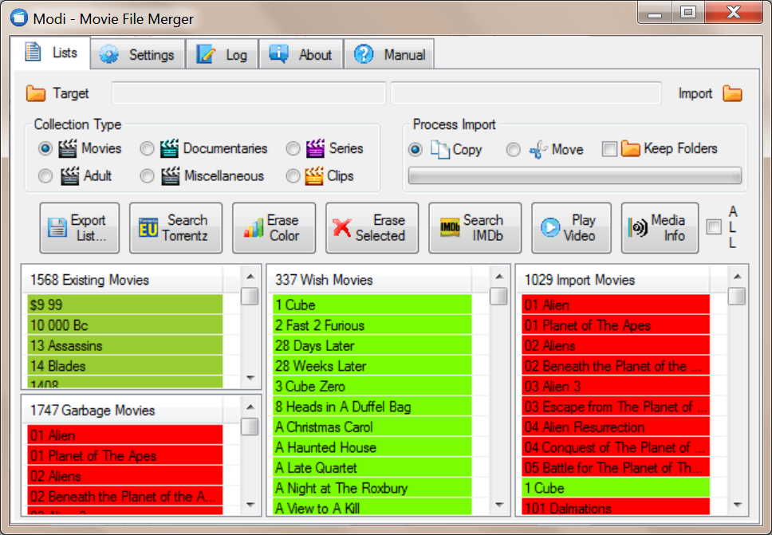

MFM is not a movie database program; hence MFM is designed so that the lists can be easily updated once out of date. MFM is designed to run in Dropbox, hence makes it easier to share lists with other people, update the program, and store your settings and lists in a save place. MFM is also designed to work together with multiple other programs, which can be downloaded and used for free.

The MFM Usage section explains how to work with MFM and frequent used third party programs. The MFM Settings section explains the configuration of MFM; anyway there should be no need to change the settings. The Collection Organization section describes contains guidelines about your collection setup and the usage of “clean up” third party programs used together with MFM, so that you get most out of the features of MFM. The installation of all recommended programs is explained in the Installation section.

# MFM Usage

The video selection process is supported by Garbage, Existing and Wish lists. Items are colored, so that you can concentrate on the difference of the collections. Items to be processed can be selected from the lists, which have been previously generated by MFM, without the presents of the actual files. Additional information about the items can be searched on IMDb. After the selection has been done, MFM can be connected to the hard disks and the actual processing started. Items that do not need to be considered can be erased from the Import list, because MFM is designed so that the Import list can be scanned in newly quite fast or reloaded. MFM does not rename, delete or modify any files, just copy or move them.

MFM is designed to work together with or beside several **other programs**... See the MFM Usage and Installation section for details about their usage, installation and setup. For more details about the usage of third party programs please consult the according user manuals. The best way is to split the screen in two halves, put MFM on the left hand side and the other program on the right hand side. Drag windows on their title bar, either to the left or to the right edge, to automatically resize the window to half of the screen.

Here are some **explanations** about terms and how they are used in conjunction with MFM... A Collection Type is the main type of the items which you want to process at this moment. An item is the sum of combined files belonging to a name. A list is a collection of items with similar properties. Names are reduced and standardized, to make it easier to match items. Items are shown in the lists. A Drop Area is an area where you can drop an item or items to perform various actions on them. An episode identifier is the part of the files name which tells MFM which episode is a file in which season of a series.

When you change the collection type or exit MFM, MFM will ask you if it should **save changed lists** to your hard disk. There is no undo function in MFM, so save your lists from time to time and if something goes wrong just discard the recent changes.

## Basic Steps

**Create a list of your existing items**, by adding all top level folders of one collection type on all your hard disks to the Existing list. Save the Existing list, by switching to another collection type. Use Save List As... to export the list for later processing or as a backup.

**Get an Import folder** or a list from Dropbox, so that you can see which items you have and which garbage are. Erase the existing and garbage items from the Import list, so that only new items and wish items are left in the Import list.

**Mark the new items** as Garbage if you don’t want to have them or as Wish to process them if they should be copied or moved to the Target folder. Save the Garbage and the Wish lists.

**To process your items**, select if you want to copy or move the items to process from the Import folder. Check Keep Folders if the folder structure in the Import folder should be kept. To flatten the folder structure, uncheck Keep Folders. Click on the progress bar to process the items. Wait until the processing is finished.

Repeat the procedure until no new items are left in the Import list.

## Select the Collection Type

A collection is the sum of items, which match certain criteria, like Movies, Documentaries or Series. Try to keep the collections in separate top level folders on your hard disks, to make your life easier when processing your collections.

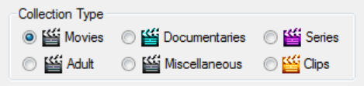

The Series collection type is treated differently from the other collection types, since its items should have an episode identifier in the file name. The item names of episodes are cute after the episode identifier in the Garbage and to the Wish lists, which tells MFM that a series is garbage or you want to have it. In the Existing and the Import list, the items names are cut after the episode identifier, so that MFM can find out which episode are missing.

All other collections are treated like the Movies collection. Item names are usually cute before the year, so that they can be compared easier.

You can set how exactly the item names are unified in the settings. To make the lists better comparable between different users it is recommended that the settings are changed as little as possible.

## Use the Drop Areas

Drop items from the lists on the drop areas to perform actions on them, like save a list, search the internet, erase items for a list, play the video, or get detailed video format information.



### Export List

Drop a single item from any list here to export the complete list. The exported list can then be imported again by dropping it on any list. Use Export List to share your lists over Dropbox or make your own backup. The working lists do not have to be exported, since they are saved automatically by MFM in your MFM Private folder.

### Search Torrentz

Drop a single or multiple items here to search for the titles on Torrentz.eu. Your default web browser will be used for the search. To do the actual download, you have to install a torrent client like uTorrrent.

### Erase Color

Drop a single item of any list here to erase all items of the same colour from the list. You can for example erase all Garbage movies from your Existing list or you can erase all existing movies from the Wish list after they have been processed. To shorten the Import list and ease the selection process, you can erase all Garbage, Existing, and Wish items, because the Import list can be reloaded once the selection process is finished.

### Erase Selected

Drop an item or an item selection here to erase all selected items from a list. You can select multiple items with the mouse by clicking in the empty column to the right of the item title column. If you use the keyboard, you can select multiple items with the Shift key. Single selected items can also be deleted with the Delete key. Use Erase Selected to clear a complete list, be selecting all if the items with the mouse.

### Search IMDb

Drop an item or an item selection here to search for the titles on IMDb. You can select multiple items with the mouse by clicking in the empty column to the right of the item title column. You can also double click a single item in any list to search for the title on IMDb. Your default web browser will be used to perform the internet search.

### Play Video

Drop a single item from the Import list here to play the video. If MFM does not find the video file in the Import folder nothing happens. Your default media player will be used to play the video. If the Import folder is available, Play Video is probably the most effective way to know what you get.

### Media Info – ALL Check Box

Drop an item selection from the Import list here to show the detailed media information with MediaInfo. If MFM does not find the video files in the import folder nothing happens. You have to install MediaInfo first to enable this option.

If the **All check box** is checked, more detailed information will be added to the popup info, when you drop a file or folder in the lists. The popup info will be shown when you hover with the mouse over an item. Check ALL before you update your Existing list and export them, so that other people have more information about the quality of the items. To read the additional information takes considerable time. To significantly speed up the processing, uncheck the ALL check box, so that only the basic information has to be read.

## Use the Lists

Each collection is split into 3 lists. The **Garbage, Existing, and Wish lists** are stored in a collection. A list is the sum of all items of a certain collection type, which match certain criteria, like you don’t want to have them, you have them, or you want to have them. The **Import list** items are not stored in the collections, but have to be imported new each time from a folder or an exported list.

The **Garbage list** is the collection of items, which you do not want to have. It includes also misspelled names. The **Existing list** is the collection of items, which you have. It can include also garbage items. The Wish list is the collection of items, which you want to have. The **Wish list** can include also Garbage and Existing items. The **Import list** is the collection of items, which are available from an exported list or a folder on the hard disk.

If you hover the mouse over a list item a **pop-up info** is shown containing information about the item, like file size, file name, or resolution… What is shown depends on the how the item is scanned or if it comes from a precompiled list.

The lists are handled by selecting items and performing the desired action on them. To **select multiple items** with the mouse, use the right most column (no header, quite thin and empty) and move the mouse over all items, which should be selected.

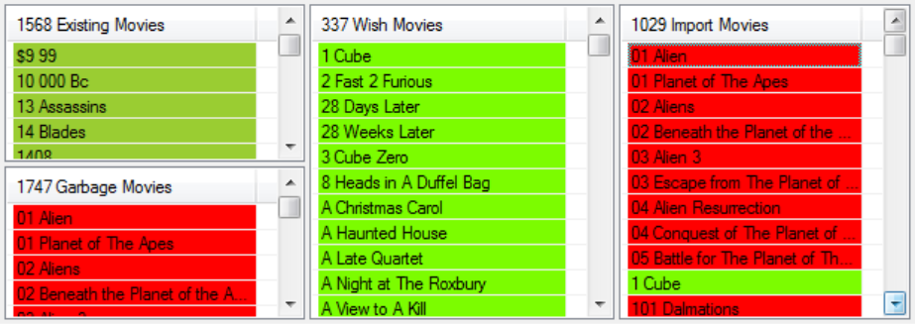

To **add items to a list** from a top level folder, drag the folder from the Windows Explorer and drop it on the list. The add items from an exported list to a list, drag the exported list from the Windows Explorer and drop it on any list. The pop-up info of items in the list will not be overwritten and only new items added to the list. Only relevant unified items are added to a list when the items are read from a folder. Unified items means that if there are more files for the same item, like a video file and a subtitle file, only one entry will be shown in the list. MFM tries to keep the item names short to make them easier to read and to compare. Files which are not relevant for MFM will not be shown in the lists.

All **lists are drop areas**, for items, for list exports and for folders. To move items from one list to another, drag and drop items from one list to another list. To delete items from a list, select them and press the Delete key. Only the lists are changed, but the files still remain where they are.

If the collection type is changed or MFM closed it will ask you if you want to **save any changed lists**, except the Import list.

MFM uses **unified item names** and combines different file types, to make the processing easier. The rules how to unify the items names can be set with regular expressions in the Setting tab.

Note: You should organize your stuff in folders according to the collection types like Movies, Series, or Documentaries to make it easier to populate the lists.

### Garbage List

Garbage items are **colored red**. The Garbage list contains all items you don’t want to have and probably don't have on any of your hard disks. To put an item in the Garbage list can mean also that the name is spelled wrong or that it is in the wrong collection category. It does not necessarily mean that the movie itself is garbage. To add items to the Garbage list drag and drop items from any other list.

Note: It the Collection Type Series is selected, only the titles of the series are shown, but not the individual files. In order to make this work a valid Episodes Identification has to be contained in the file names.

### Existing List

Existing items are **colored dark green**. The Existing list contains the items you have on your hard disks. To add items to the Existing list drag and drop the top level folders from the Windows Explorer on the Existing list. After a while your Existing list will get out of sync with the stuff you actual have. To get an up to date Existing list erase all items and populate the list again with the top level folders from your hard disks.

### Wish List

Wish items are **colored light green**. The Wish list contains items you want to have. To add items to the Wish list drag and drop items from the Import list on the Wish list. After you have copied the items they will appear in the Wish list. To clean up the Wish list, erase the Garbage and Existing items.

Note: It the Collection Type Series is selected, only the titles of the series are shown, but not the individual files. In order to make the work a valid Episodes Identification has to be contained in the file name.

### Import List

The Import list contains all the items, which should be processed and is a mixture of Existing, Garbage and New items, to combine with your existing collection. To prepare the processing populate the Import list from previously saved .csv files. Move the items to the other lists and save them for later processing. To start the actual processing the Import list has to be populated from a folder on a connected hard disk.

## MFM and Dropbox

Some information from <https://www.dropbox.com> is shown here. *"One place for all your stuff, wherever you are." Dropbox is a home for all your photos, docs, videos, and files. Anything you add to Dropbox will automatically show up on all your* [*computers*](https://www.dropbox.com/install)*,* [*phones*](https://www.dropbox.com/mobile) *and even the* [*Dropbox website*](https://www.dropbox.com/) *— so you can access your stuff from anywhere. Dropbox also makes it super easy to share with others, whether you're a student or professional, parent or grandparent. Even if you accidentally spill a latte on your laptop, have no fear! Relax knowing that your stuff is safe in Dropbox and will never be lost.*

MFM is designed to be executed as a whole in Dropbox. Use Dropbox to share your lists with your friends. Dropbox is best used to the right side of MFM in the Windows Explorer. Basically there are three folders in Dropbox, which are relevant for MFM...

MFM Program – Contains files need for the execution of MFM. To start MFM double click on Movie File Merger.exe. Create a shortcut on your desktop of easy access of MFM.

MFM Private – Contains your private copy of the initialization file and your collections, which are loaded be default from MFM. The first time your start MFM it will create this folder at the same level of the MFM Program folder. It contains also the TeraCopy Lists folder, where MFM stores the lists, which have been previously processed.

MFM Collection – Contains the collections for sharing and is the standard folder for MFM. Export and import lists here to share with your friends. You can make as many independent collections folders as you want and share with different groups of friends.

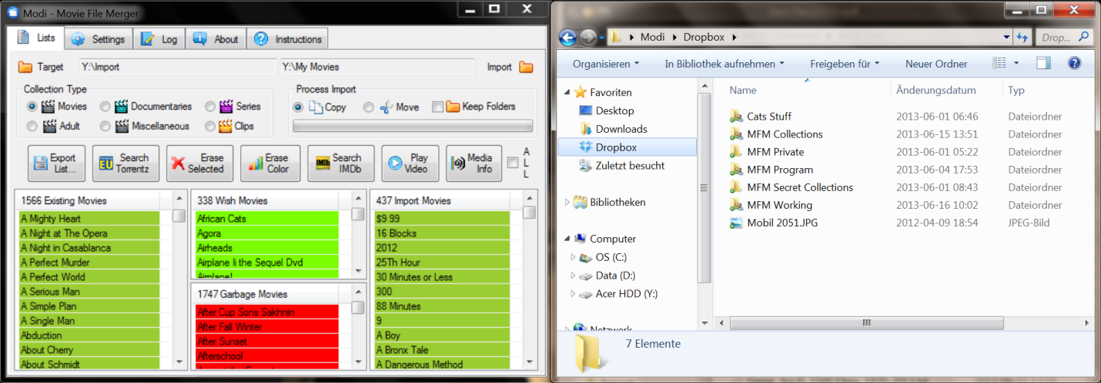

To manage your Dropbox, click on the Dropbox item in the Windows System Tray and select Dropbox.com. You can then invite other people to your collection folder.

Use Windows Explorerto drag and drop folders or list files into MFM. I would recommend you to place Windows Explorer to the right of MFM. To place a window so that it occupies half of the screen, drag it on the title bar to the very right or left side of the screen.

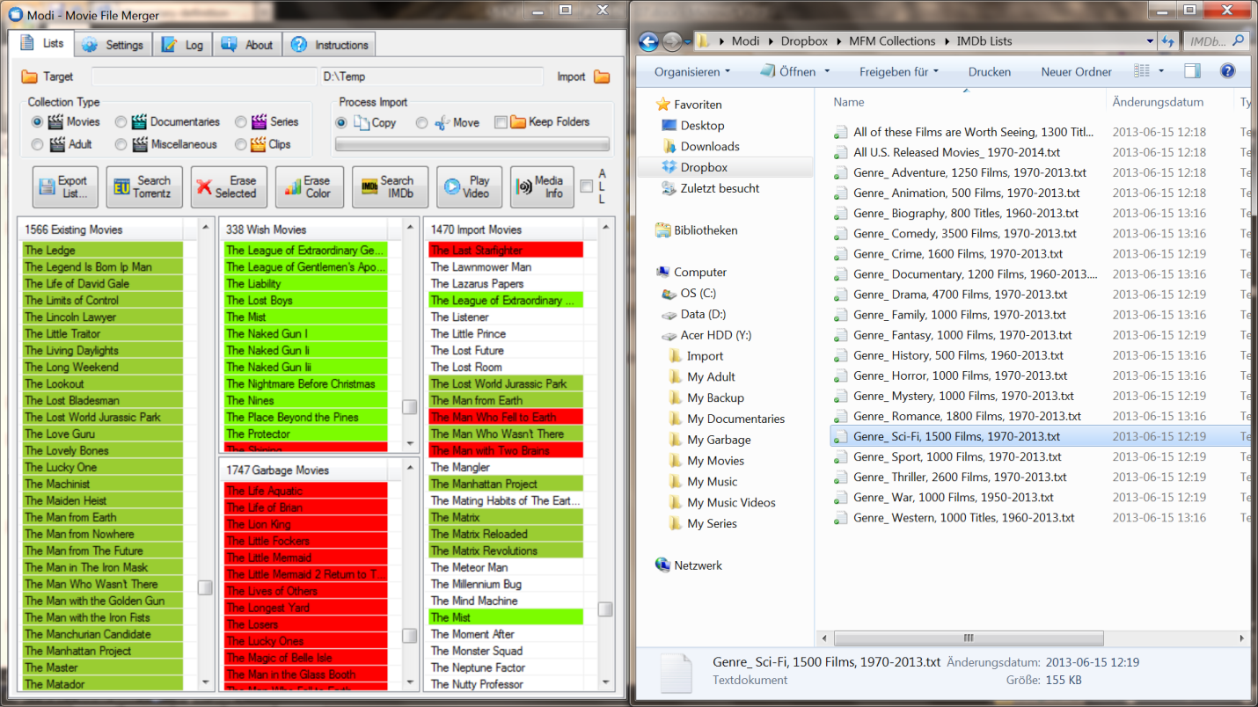

MFM uses just a few percent of the free Dropbox online storage, so that you can use Dropbox also for other things, like sharing your photos with your friends, which is much, much easier over Dropbox then over e-mail. Note also that every time you recommend a new user for Dropbox your and their free on-line storage will be increased by 500 MB to a maximum of 16 GB. All you need is the e-mail of your friend, for which Dropbox should be registered.

## MFM and GOM

You can find more information about GOM Media Player on <http://player.gomlab.com/eng>. *Not only is GOM Media Player a completely FREE video player, with its built-in support for all the most popular video and audio formats, tons of advanced features, extreme customizability, and the Codec Finder service, GOM Media Player is sure to fulfil all of your playback needs. With millions of users in hundreds of countries, GOM Media Player is one of the world`s most popular video players.*

Use GOM Media Player (or any other player of your choice) to view a video. Drag an item from the Import list on Play Video. MFM searches for the item in the Import Folder, if MFM does not find the item nothing will happen.

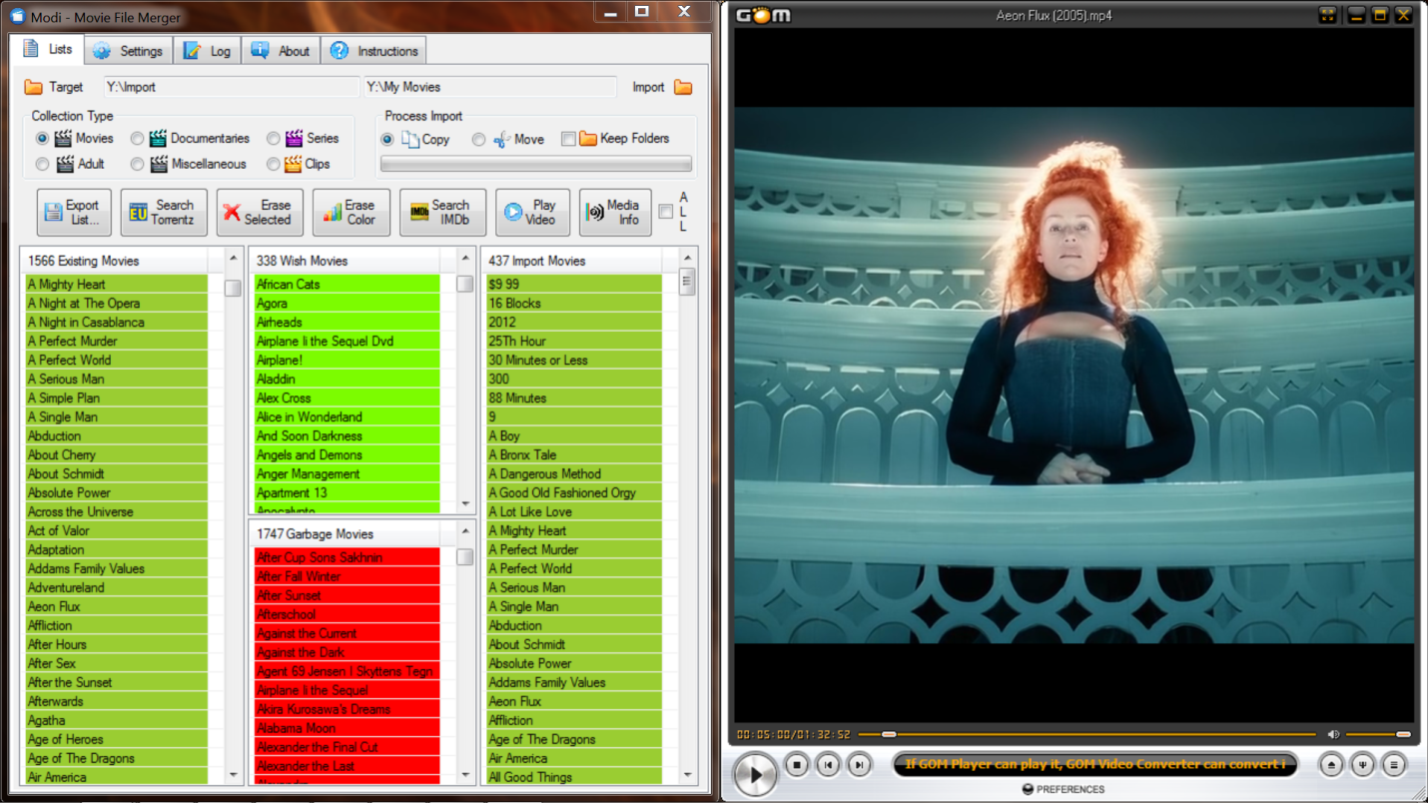

To use a player is probably the most effect method to get more information about the actual video, since you can judge the quality and content yourself.

## MFM and IMDb

You can find more information about IMDb on <http://www.imdb.com>. *The Internet Movie Database (IMDb) is an online database of information related to* [*films*](http://en.wikipedia.org/wiki/Film)*,* [*television programs*](http://en.wikipedia.org/wiki/Television_program)*, and* [*video games*](http://en.wikipedia.org/wiki/Video_games)*. This includes* [*actors*](http://en.wikipedia.org/wiki/Actors)*, production crew personnel, and fictional characters featured in these three visual entertainment media.*

Use IMDb to get additional information about movies, series, or documentaries. Further, you can also export lists from IMDb, process them a little bit in MS Excel and drop them into your MFM lists.

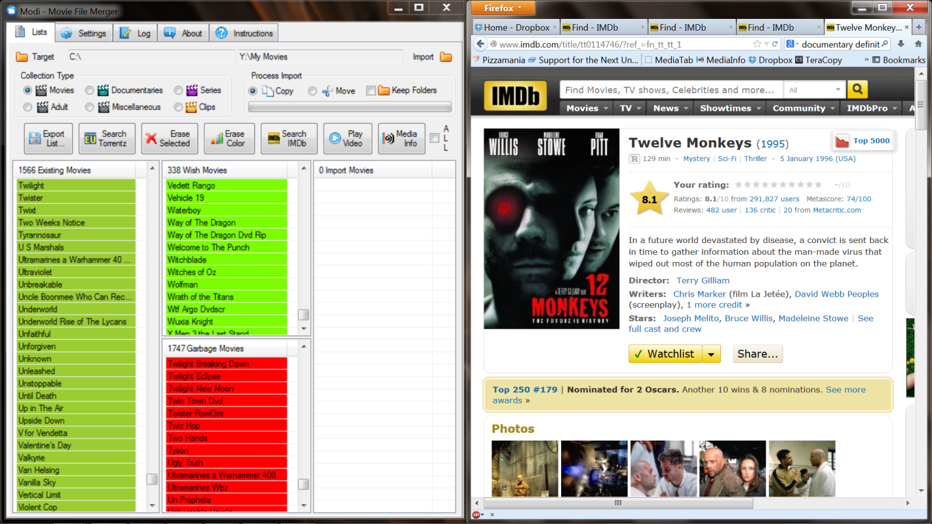

Firefox (or any other web browser, depending on what you have set in your system settings) is used to search IMDb. Firefox is Ok to run either on the left or the right side of MFM.

Whole categories of movies, downloaded from IMDb, can be added to the Garbage list. For example export a list with Sport movies from IMDb, open the exported list with MS Excel, delete not wanted columns, make the title column the first column and then save the file as tabulator delimited text file. Drop the file in your Garbage list. The first column will be used as item title; the other columns will be added to the popup info. If you like Sci-fi movies then you can drop the Sci-fi list in your Wish list and whenever MFM find a Sci-fi movie it will be copied.

## Set the Folders

There are two folders, which are relevant for the processing of files, the Target and the Import folder. When you click the progress bar the files which match the Wish items in the Import list are copied or moved from the Import folder to the Target folder.



### Target Folder

The Target folder is the folder where you want to copy or move your wish movies to. Drop a folder from the Windows Explorer into the text field beside the Target folder icon.

If items are found in the Target folder they are added to the Existing list. It is recommended to make a folder structure in your target folder similar to the collection types you are processing. For example you could have a Movies, a Documentaries, and a Series folder in the Target folder.

### Import Folder

The import folder is set automatically when you drop a folder or file in the Import list. If a file or multiple folders are dropped in the Import list the according top level folder is used. If you drop a folder in the text field to the left of the Import icon the import list is automatically populated.

## Process the Import

The process Import section allows you to copy or move the actual video and subtitle files. You have to install TeraCopy to do the actual processing. See the Installation section how to setup TeraCopy so that it does not replace the default Windows copy or move.

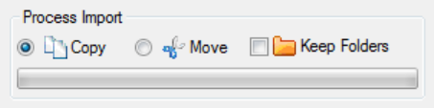

### Copy

If Copy is selected and you click the Progress Bar, the Wish coloured items in the Import list will be copied to the Target folder. Actually, MFM does not do the copying, but just prepares a list which it hands over to TeraCopy. As soon as MFM has handed over the list, you can continue selecting the items you want to process next. You can start the next copy process even if TeraCopy is still running. New items will be added the TeraCopy waiting list and processed when the time has come.

### Move

If Move is checked and the Progress Bar clicked, the Wish coloured items in the Import list will be moved to the Target folder. Actually, MFM does not do the moving, but just prepares a list which it hands over to TeraCopy. As soon as MFM has handed over the list, you can continue selecting the items you want to process next. You can start the next moving process even if TeraCopy is still running. New items will be added the TeraCopy waiting list and processed when the time has come.

### Keep Folders

If Keep Folders is checked the folder structure of the Import folder will be recreated in the Target folder. Only folders which contain items that are copied or moved are created. To keep the keep the folder structure is especially useful for series. For movies I would recommend to flatten the folder structure.

### Progress Bar

Click the progress bar to start the processing. MFM will create list files and hand them over to TeraCopy, which does the actual copying or moving. As soon as MFM has handed over the list, you can continue selecting the items you want to process next.

## MFM and MediaInfo

You can find more information about MediaInfo on <http://mediainfo.sourceforge.net>. *MediaInfo is a convenient unified display of the most relevant technical and tag data for video and audio files.*

Use MediaInfo to get detailed information about the video files.

Drag an item from the Import list on MediaInfo... MFM searches for the item in the Import Folder, it MFM does not find the item nothing will happen.

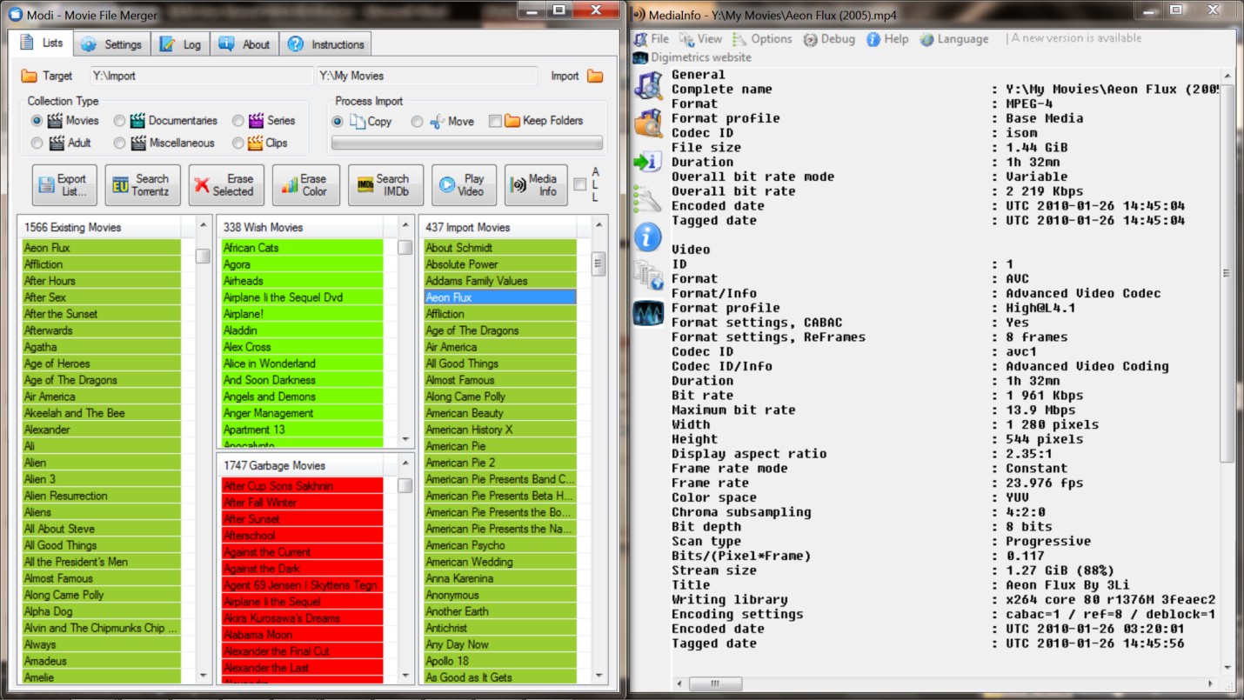

## MFM and PVD

You can find more information about PVD on <http://www.videodb.info/forum_en>. *With Personal Video Database you can catalogue your movie collection fast and easy. Thought-out user interface and different database management function make it easy to create and manage big movie databases. Powerful filtering, grouping and sorting help you find movies very fast.*

Use Personal Video Database to generate lists of movies according to certain filter criteria or to rename movies to their standard names. It is important that movies have good names, preferably from IMDb.

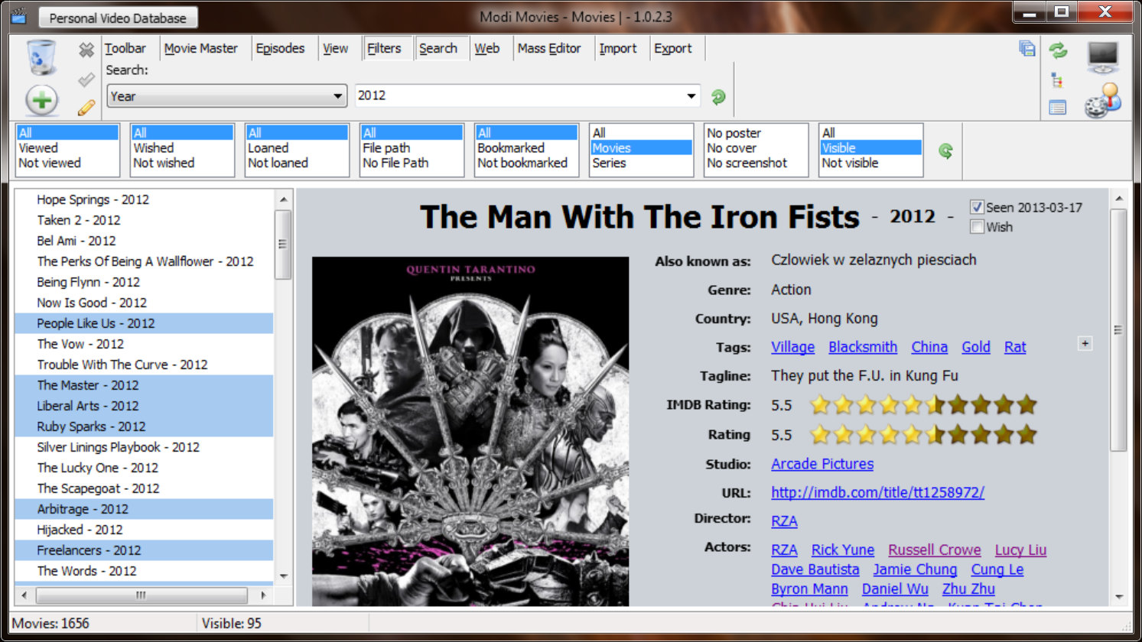

With advanced filter you can setup complex criteria, and then export the list. Clean up the exported list, with a text editor like Notepad++, so that only the movie names are in the list, and then drop it into MFM.

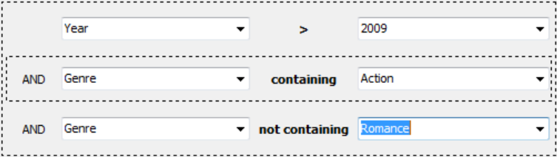

## MFM and Torrentz

You can find more information about Torrentz on <http://torrentz.eu/>

1. *Torrentz is a* [*meta-search engine*](http://en.wikipedia.org/wiki/Metasearch_engine) *(*[*aggregator*](http://en.wikipedia.org/wiki/Search_aggregator)*) and a* [*Multisearch*](http://en.wikipedia.org/wiki/Multisearch)*. This means we just search other search engines.*
2. *Torrentz is a very powerful internet location search tool.*
3. *Torrentz is neither a torrent cache, torrent tracker nor a torrent directory.*
4. *Torrentz does not host or "make available" any files or torrents in any way, shape or form.*
5. *Torrentz links to other independent search engines that might host torrent files. We have absolutely no control over those domains.*
6. *Indexing process is completely automated. We don't check it. Whatever the stupid bots suck in goes. The good, the bad and the ugly.*
7. *Torrent files are simply metadata and cannot be copyrighted.*
8. *We don't host torrents; we don't even save torrents for ourselves after the filename and size extraction.*
9. *Torrentz is similar to Google.*
10. *Torrentz will gladly remove any links at copyright owner's request. Read Takedown Policy below.*
11. *Torrentz has been around for well over 9 years now.*
12. *Torrentz has a spotless relationship with copyright owners and governmental organizations (Child protection, etc).*
13. *Torrentz respects reasonable copyrights and acts in compliance with EUCD and DMCA. Yes, Really.*
14. *Torrentz loves you.*

Use Torrentz to download any video you want to have immediately. Drag an item from the Import list on Search Torrentz.

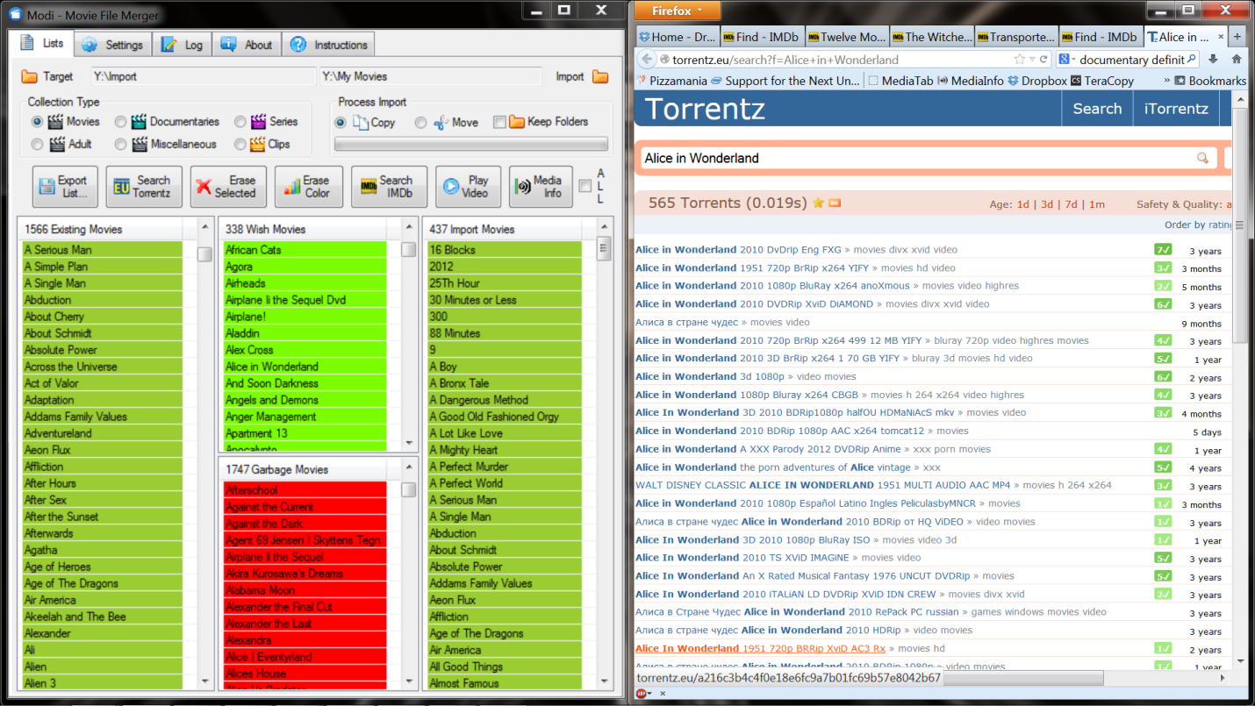

## Share Rings

You can open share rings with your friends, to distribute videos. A share ring is a group of people, who live in same area, can meet each other, and have a video collection on their hard disk or disks. Each member of a share ring scans its own videos with MFM and distributes the lists in the MFM Collection folder in Dropbox. Other members can then preselect the videos they want to copy at home and put them into their Wish lists. Once the hard disks are brought together, MFM extracts only the wanted videos from your friend’s hard disk.

The MFM Collection folder is used as default from MFM. If you want to open another share ring with a different group of people just make another folder and put your lists in there. There is no limitation concerning the amount of collection folders you can have. One member of the share ring will be the owner of the shared folder in Dropbox, with the right to exclude people if needed. As default from Dropbox every member can invite other people. However, the owner of the Dropbox folder can disable that option.

Since all members of a share ring compare their list with each other it is quite important to use the same naming conventions and item unification settings.

Since it is a lot of work to select videos, precompiled lists (with thousands of entries) can be downloaded from IMDb. The precompiled lists can be for genres, like sci-fi, romance, drama action... If you put a precompiled list in your wish folder MFM searches for videos of all genres in the wish list. Some precompiled lists are also provided with the MFM installation.

# MFM Settings

Most of the settings are regular expressions. See the chapter Regular Expressions at the end of MFM Settings for more information.

### Nick Name

Fill in your nick name, so that it will be shown in the pop info when the mouse is hovered over an item. It is useful to know from where an item comes when you populate your wish list from more than one source.

## Considered Files Settings

MFM only considers files which have certain extensions. Files which are not relevant are ignored.

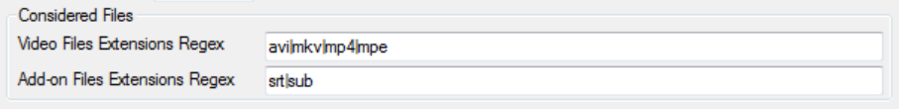

### Video Files Extension

The Video Files Extension regular expression identifies main video files. If no main file exists also the add-on files will be ignored. Keep the list as short as possible to speed up the file processing. Add all wanted video file extensions separated with a vertical line “|”.

### Add-on Files Extension

The Add-on Files Extension identified add-on files like subtitles or posters. Add-on files will be only considered if a main video file exists. Add all wanted add-on file extensions separated with a vertical line “|”.

## Name Unification Settings

MFM tries to unify the names of items, so that they can be better read and compared.

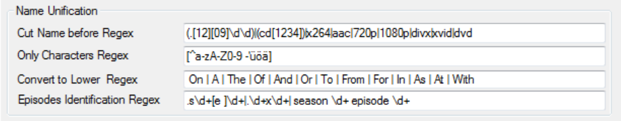

### Cut Name Before

The Cut Name Before regular expression tells MFM what not to include in the name. Everything after, including the match itself, will be removed from the item name. For example the year is good to remove, because the same movie can have different years in different collections. The disadvantage is that two different item with the same name, but a different year, will be treated as one. This regular expression is a little bit more complicated; please consult the Regular Expression Explanation chapter for more information.

### Only Characters

The Only Characters regular expression tells MFM which characters to accept. All other characters will be removed from the item name. The only character regular expression has to start with “[^” and end with “]”. All characters, which should be included in the unified item name, have to be written in the middle.

### Convert to Lower

MFM capitalizes the first letter of each word in a name by default, to make the item name easier to read. The Convert to Lower regular expression tells MFM which words in the name to convert to lower case. The convert to lower regular expression contains the articles between spaces “ “ separated by a vertical line “|”.

### Episodes Identification

The Episodes Identification regular expression tells MFM where to find the episode identification in the file name. The episode identification has to contain 2 numbers of which the first number is for the season and the second number for the episode. Episode names will be truncated after the episode identification. Series names will be truncated before the episode identification. The regular expression “\d+” means a number with any amount of digits. Different episode identifications have to be separated by a vertical line “|”.

## Supporting Programs Installation Paths Settings

MFM uses just 2 programs which are called direct; TeraCopy and Media info. Other programs, like the web browser and the media player, are launched by executing the file or http address.

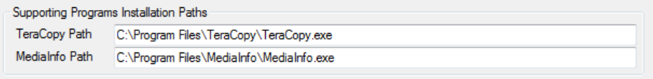

Note that even when the German version of Windows 7 is installed and the “Program Files” folder is called “Programme” in the Windows explorer the paths work also with “Program Files”. That means if the default settings are used during the installation there should be no need the change these settings.

### TeraCopy Path

The TeraCopy Path points to where you have installed TeraCopy.

### MediaInfo Path

The MediaInfo Path points to where you have installed MediaInfo.

## Brief Regular Expressions Explanation

Regular expressions can be very complicated, but MFM uses just basic regular expressions and it should be possible to figure out how they work by looking at the standard settings.

Regular expressions can be tested on <http://rubular.com>.

An over view of regular expression can be found on Wikipedia under <http://en.wikipedia.org/wiki/Regular_expression> from where also the following excerpt is. You can find it also directly on the Setting tab, where regular expressions are used in MFM.

A regular expression, often called a pattern, is an expression that specifies a set of strings. To specify such sets of strings, rules are often more concise than lists of a set's members. For example, the set containing the three strings "Handel", "Händel", and "Haendel" can be specified by the pattern H(ä|ae?)ndel (or alternatively, it is said that the pattern matches each of the three strings). In most formalisms, if there exists at least one regex that matches a particular set then there exist an infinite number of such expressions. Most formalisms provide the following operations to construct regular expressions.

Boolean "or": A vertical bar separates alternatives. For example, gray|grey can match "gray" or "grey".

Grouping: Parentheses are used to define the scope and precedence of the operators (among other uses). For example, gray|grey and gr(a|e)y are equivalent patterns which both describe the set of "gray" and "grey".

Quantification: A quantifier after a token (such as a character) or group specifies how often that preceding element is allowed to occur. The most common quantifiers are the question mark ?, the asterisk * (derived from the Kleene star), and the plus sign + (Kleene cross).

The question mark (?) indicates there is zero or one of the preceding element. For example, colou?r matches both "color" and "colour".

The asterisk (*) indicates there is zero or more of the preceding element. For example, ab*c matches "ac", "abc", "abbc", "abbbc", and so on.

The plus sign (+) indicates there is one or more of the preceding element. For example, ab+c matches "abc", "abbc", "abbbc", and so on, but not "ac".

These constructions can be combined to form arbitrarily complex expressions, much like one can construct arithmetical expressions from umbers and the operations +, −, ×, and ÷. For example, H(ae?|ä)ndel and H(a|ae|ä)ndel are both valid patterns which match the same strings as the earlier example, H(ä|ae?)ndel.

# The Log, About, and Instructions

MFM logs some basic actions in the log tab. Anyway, to log is not that good implemented as of now and not very useful.

The About Tab shows the version of MFM, useful links to third party programs, and the copy right.

The instructions are very brief and contain only basic information about the usage of MFM.

# Collection Organization

There are different ways how to organize your collection. Some people have no organization at all and that’s the worst case. Most people have a basic separation between movies or documentaries and series and that’s already better. There is simply no best way how to organize your collection; it depends on your personal preferences. MFM is designed so that it browses also through subfolders and that the organization structure doesn’t matter that much. However, it is pretty important to **keep your collections as clean as possible** on your hard disks. Below are some suggestions, which make your life easier, especially if your collection gets bigger and bigger.

## Do’s and Don’ts

Below listed are some recommendations based on my experience, so if something goes against your preferences just ignore it.

### My Dos

* Do separate your video files according to what they are. Movies, series, documentaries...
* Do use correct names. Get them from an internet database.
* Do put the year in the movie files names after the actual movie name.
* Do put the series name, the season and the episode number in the file names.
* Do combine split video files. Use AVI Mux GUI.
* Convert DVD files to single video files. Use MakeMKV.
* Do delete some videos if you run out of space. That increases the quality of your collection and saves you the money to buy a new hard disk.
* Do use your friend’s hard disk to make a back up of your good videos.

### My Don’ts

* Don’t include video format information in the names. It can be seen when using a database program like PVD or MediaInfo.
* Don’t make too many subfolders.
* Don’t keep any files not needed, like the torrent files.
* Don’t keep videos with bad quality.
* Don’t keep videos with burned in subtitles.
* Don’t keep movies in format 4:3 if they should be at least 16:9. Or at least move them in a folder for bad quality movies.
* Don’t rename you files manually. Use FileBot.
* Don’t keep not used subtitle files. If needed they can be download again.
* Don’t keep your videos in zip or rar files. Videos are already compressed and normally cannot be compressed more.
* Don’t worry too much that you will lose a file, most likely you can get it again.

## General Organization

Make **top level folders** for My Documentaries, My Movies, and My Series. To add “My” in front of the collection types has the advantage that all collections are beside each other on the hard disk, even if you put other stuff on there. “My” could be also replaced with your nick name or similar. Put movies, series and documentaries in their own top level folders. A good idea is also to make a My Garbage folder and put all movies in there which you probably will delete, but you are not sure for now, because maybe some other people like them. If you later run out of space and need more to put on new stuff, you just have to delete the files in My Garbage without thinking too much what to delete during that stressful time. You can make a folder structure on lower levels as you like and there is no limit to the number of subfolders you can make.

To avoid **distributing stuff with bad quality** or stuff which is simply not good, I recommend that you delete real crap immediately, since probably nobody wants to have it anyway.

If you have **more than one hard disk**, implement the same structure on every hard disk. That way, if one of your hard disks dies, you lose only a part of each collection, but not a complete collection. Then there is also no need to move stuff around all the time and if a hard disk is full you just buy a new one and put your stuff on there. If you have an old hard disk, or a hard disk, which seems to be breaking down soon, you could put all the stuff on there, which you like least or with just acceptable quality. If the sick hard disk then breaks down the average quality of your collections, will immediately improve a lot...

If you have a **messed up folder structure** where video files and other files (poster, torrent files...) are mixed together you can move out important files (video and subtitles) with MFM. MFM does not touch other files, so that you can review if there is any important file left in the messed up “empty” folder structure. Check the file names before moving the files, because sometimes files in folders are not named according to the content. If you drop the top level folder into MFM you can see the list of all files and scan that one for strange names. If nothing important is left just delete the whole folder structure.

If you have **multiple files** for the same movie, like cd1 and cd2, then they should be combined using AVI Mux GUI. If the files are still in the DVD structure you can use MakeMKV to convert them to a single video files. Both programs are more or less as fast as if the movie is just copied. The limit is how fast your computer can read and write to the hard disks. To speed up the processing it is better to convert the files from one hard disk to another.

To make the comparison as easy as possible some **basic naming guide lines** should be followed. FileBot is good to get the correct names from internet databases and rename your movies and series. If the names are that strange that FileBot cannot find them on the internet File Renamer Basic can be used to fix them so that FileBot can find them and make them 100% correct. If you share your collection with your friends it is important to have the same names for the same stuff, otherwise they will be treated as different videos by MFM.

### Movies

A movie is a video telling **a fictive story** by the use of actors or a story or event recorded by a camera as a set of moving images and shown in a theatre or on television; a motion picture. Movies should be only actual movies and not be confused with Documentaries or Series. Even if a movie is based on a real story it is no documentary. Some sample movies are...

|  |  |  |  |
| --- | --- | --- | --- |
| The Lord of the Rings: The Two Towers | Pirates of the Caribbean: At World's End | The Silence of the Lambs | Red Dragon |

When the name of a movie is processed, it is reduced according to certain criteria to ease the matching of the movies. MFM tries to cleanup Movie names, by cutting them of before the year, in the files name. If no year is found it is tried to clean up the name according to some other criteria. However, the better the naming of the files is that better MFM works.

|  |  |
| --- | --- |
| The recommended naming format for movies is… <Movie Title> (<year>)  The important thing is that the year is immediately after the name. If round brackets are used or not is not that important and the main reason is readability. |  |

I would recommend having no subfolders for each movie. If you want to can separate your movies somehow according to genres, but the challenge with this implementation is that all movies are of more than one genre, like action comedy or a romance drama. To get a good overview of all the stuff you have you can use a database program like the Personal Video Database. PVD can download information from the IMDb. With PVD you can mark you movies as seen and filter or sort them according to many criteria.

### Documentaries

A documentary is video that is telling **a more real story** by the use of presenters or a movie or a television program that provides a factual record or report. Documentaries are treated like movies concerning the item names. Some sample Documentaries are...

|  |  |  |  |
| --- | --- | --- | --- |
| Human Planet | Life | Planet Earth | Wonders of the Solar System |

|  |  |
| --- | --- |
| There is no recommended format concerning the documentaries. Depending on the documentation, either Movie format or Series format can be applied. |  |

### Series

Series are a video **collection telling a fictive story** in multiple parts or episodes by the use of actors. Series are set of related television programs, esp. of a specified kind: "a new drama series". Some sample Series are...

|  |  |  |  |
| --- | --- | --- | --- |
| FlashForward | The X-Files | Lie to Me | Law & Order: Criminal Intent |

The Series collection is treated, different from the Movies collection. Items in the Garbage or Wish list are even reduced further, to the Series title. The Existing and Import lists contain also the episode identifier. The episode title is removed after the episode identifier, to enable better matching of the episodes.

|  |  |
| --- | --- |
| The recommended naming formats for episodes are…  <Series Name> S<Season Number>E<Episode Number> <Episode Title>  <Series Name> <Season Number>x<Episode Number> <Episode Title>  <Series Name> season <Season Number> episode <Episode Number> <Episode Title> |  |

The series should be in a folder for the each series and subfolders for each season.

### Miscellaneous

Use this collection for any video of any kind. It is opened as default. The Miscellaneous collection is treated like the Movies collection concerning the unified item names. It can be also used as temporarily collection to clean up your collections.

### Adult and Clips

An Adult video is telling a fictive story by the use of special actors, which should not be watched by persons under 18 years. The Adult collection is treated like the Movies collection concerning the unified item names.

A clip is a short video telling the story of a song by using dancers. The Clips collection is treated like the Movies collection concerning the unified item names.

## Clean Up Programs

### FileBot to Rename Movies and Series

You can find more information about FileBot on <http://www.filebot.net>. ***FileBot*** *is the ultimate tool for organizing and renaming your movies, TV shows or anime, and music well as downloading subtitles and artwork. It's smart and just works.*

Use FileBot to rename movies or series to their standard names. It is important that series have good names and episode identifiers. Similarly it is important that movies have good name, so that the list can be matched as good as possible.

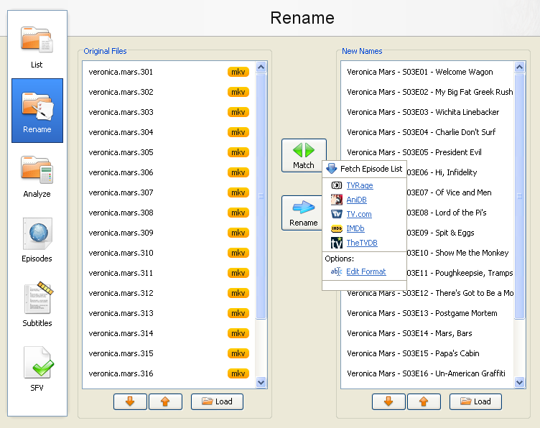

Just drop the series folder of movies in the left list, right click match, and select The TVDB. After FileBot found the title in the online database, click on Rename. If FileBot asks you to validate the name, do so, and click continue.

### File Renamer Basic to Fix Serious Naming Problems

You can find more information on <http://www.sherrodcomputers.com/products_filerenamer.cfm>. *File Renamer was developed to easily and quickly rename multiple files at once. With this program, you can rename entire directories and subdirectories of files/Images/Photos at once with a powerful preview and with multiple tools. It was designed to be easy to use yet powerful enough to handle some of the most complex tasks. File Renamer is also perfect for renaming digital pictures. Select the pictures you want to rename, choose the new file name scheme, apply, you're done! - It's that easy!*

Use File Renamer Basic to fix serious problems with you file name, like for example if the Series name is missing in front of the episodes.

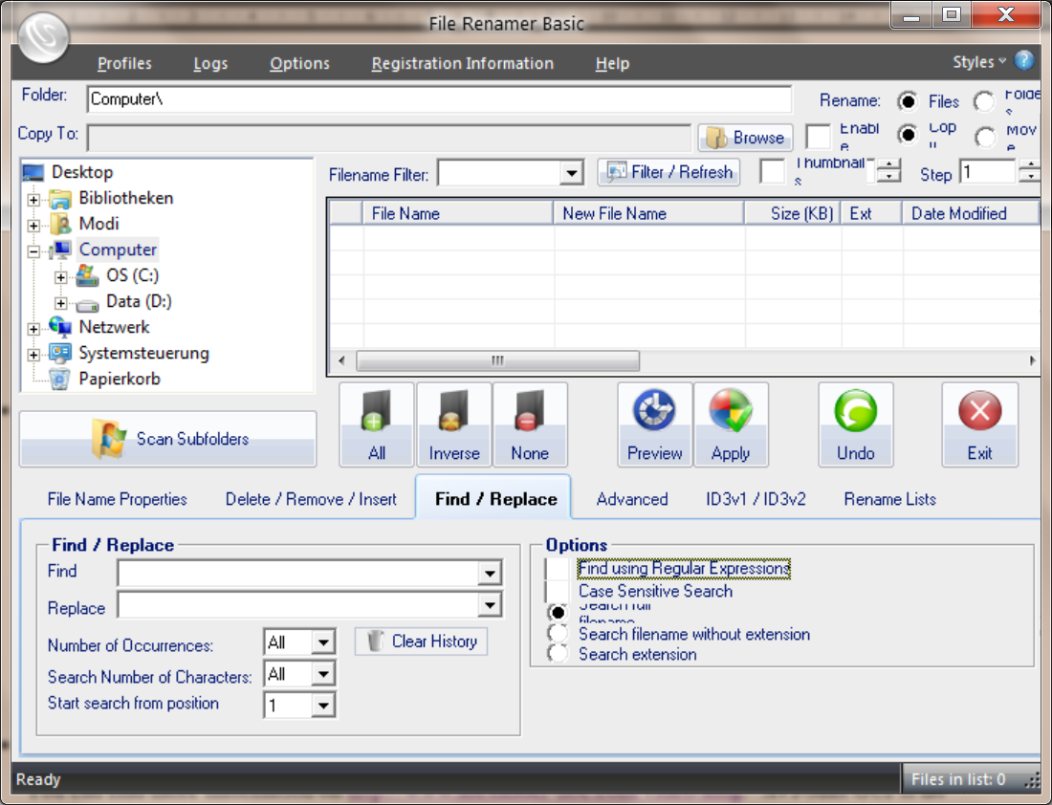

### AVI Mux GUI to Combine Videos Split Over More Files

You can find more information on <http://www.alexander-noe.com/video/amg>. *AVI-Mux GUI is an application that allows to combine several video, audio or subtitle files into one file, without size restriction, allowing configuring properties of the output file to a deeper level than usual for such applications.*

Use AVI Mux GUI to combine movies that are split in two CDs or more. Drop the files in the top list and select all files in the list. AVI Mux GUI can only combine files with the same format and resolution.

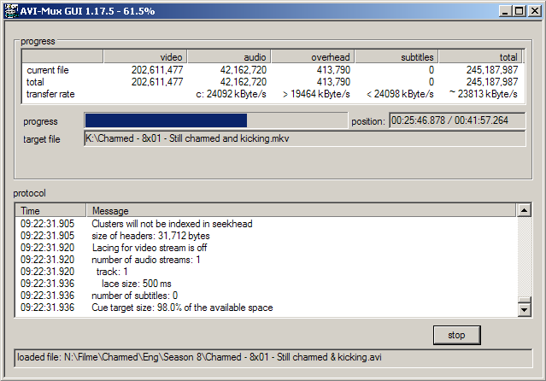

### MakeMKV to Convert DVDs to Single Files

|  |  |
| --- | --- |
| You can find more information on <http://www.makemkv.com>. *MakeMKV is your one-click solution to convert video that you own into free and patents-unencumbered format that can be played everywhere. MakeMKV is a format converter otherwise called "transcoder". It converts the video clips from proprietary (and usually encrypted) disc into a set of MKV files, preserving most information but not changing it in any way. The MKV format can store multiple video/audio tracks with all meta-information and preserve chapters. There are many players that can play MKV files nearly on all platforms, and there are tools to convert MKV files to many formats, including DVD and Blu-ray discs.* | http://www.makemkv.com/images/sshot-t3-web.png |

Use MakeMKV to convert your DVDs to single MKV files. If movies are stored in the DVD structure as the single VOB files, MFM will not work.

# Installation

There are several other programs used together with MFM. All other programs can be downloaded and used for free. For detailed information about the installation of third party programs please consult the according documentation.

## MFM Installation

Working with Dropbox is part of the current design of the program. However the program can also work standalone, like from a memory stick or normal folder on the hard disk without Dropbox. It is recommended to copy the whole folder that contains the executable and support files into a new folder, as the program when working will create the 2 ‘Collection’ folders on the same level as its own folder. In this way it is easy to keep track of all the files that the program uses.

Double clicking on the program in its folder or starting it from a shortcut is all you need to do run it. No further installation needed.

### System Requirements

MFM runs under Windows XP*, Vista*, Windows 7, and Windows 8. MFM has also been used on a Mac with Parallels installed.

* Not tested, and needs .net framework 4.0 installed. To handle the resizing of the windows, a program like PowerResizer is required.

## TeraCopy Installation

You can find more information about TeraCopy on <http://codesector.com/teracopy>. *TeraCopy is designed to copy and move files at the maximum possible speed. It skips bad files during the copying process, and then displays them at the end of the transfer so that you can see which ones need attention. TeraCopy can automatically check the copied files for errors by calculating their CRC checksum values. It also provides a lot more information about the files being copied than its Windows counterpart. TeraCopy integrates with Windows Explorer's right-click menu and can be set as the default copy handler.*

MFM uses TeraCopy to do the actual copying or moving.

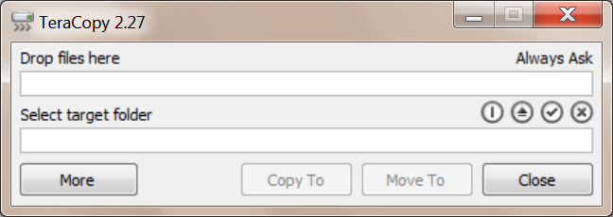

Install TeraCopy with the default settings and change them later as shown below if wanted.

To make sure TeraCopy all the time starts copying, uncheck “Check Free Space” in the Preferences. You can open the Preferences by right clicking somewhere in the TeraCopy window and selecting Preferences...

If you do not want that TeraCopy replaces the operating system copy function, uncheck Use TeraCopy as Default Copy Handler.

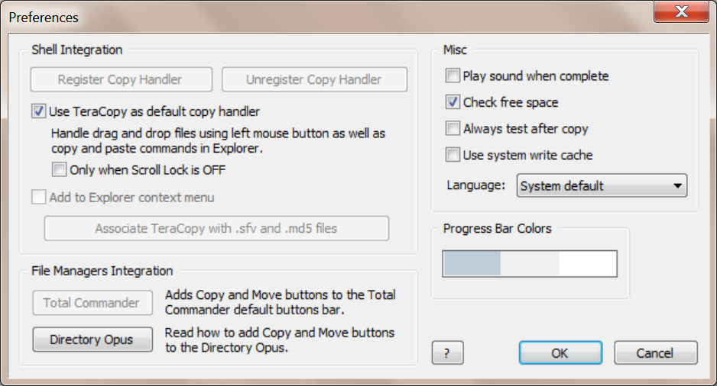

## Dropbox Installation

You can download Dropbox from <https://www.dropbox.com/install2>. To use Dropbox you will have to register your own Dropbox account. If you recommend Dropbox for other people you will get 500 MB more, if the other user is new to Dropbox and installs the Dropbox program on a computer.

## GOM Installation

You can download GOM Media Player from <http://player.gomlab.com/eng>.

Disable the option Default Playback Windows Size so that GOM Media Player will only take up the right side of your screen. You will have to move GOM there “manually”; it does not work to drag GOM there on the title bar to resize it to half of the screen.

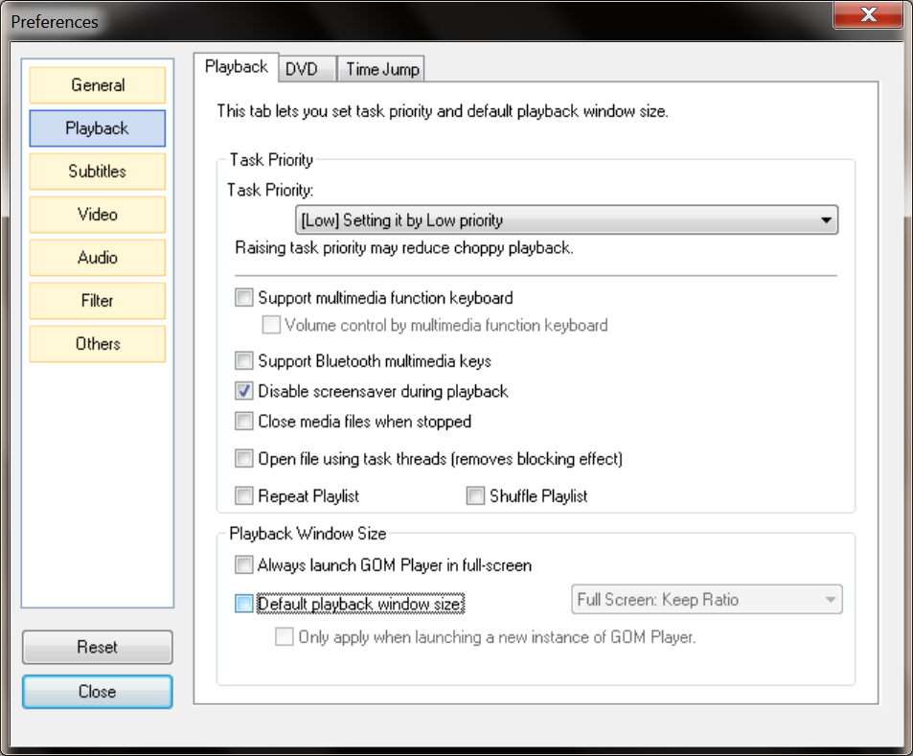

## MediaInfo Installation

You can download MediaInfo from <http://mediainfo.sourceforge.net/en>. Install MediaInfo with default settings.

## FileBot Installation

You can download FileBot from <http://www.filebot.net>. Install FileBot with the default settings. If you don’t want to install FileBot locally, it can be also launched over the internet.

## PVD Installation

You can download PVD from <http://www.videodb.info/forum_en>. I am using the beta version of PVD, which has more advanced features compared to the stable version. It runs pretty stable on my computer... Install it at your own risk to benefit form the newly added features.

## AVI Mux GUI Installation

You can download AVI Mux Gui from <http://www.alexander-noe.com/video/amg>. The development of AVI Mux GUI is discontinued, however the latest version does a very good job in combining video files.

## MakeMKV Installation

You can download MakeMKV from <http://www.makemkv.com/download>. The development of MakeMKV is discontinued, however the latest version does a very good job in converting video files, to single MKV files.

# Index

A

About 22

Add-on Files Extension Settings 20

Adult 28

ALL Check Box 8

AVI Mux GUI 30

AVI Mux GUI Installation 34

B

Basic Steps 6

C

Clips 28

Collection Organization 24

Collection Type 7

Combine Videos 30

Considered Files Settings 20

Convert DVDs 31

Convert to Lower Setting 21

Copy Radio Box 15

Cut Name Before Setting 20

D

Documentaries 26

Drop Areas 7

Dropbox Installation 33

Dropbox Usage 10

E

Episodes Identification Setting 21

Erase Color Drop Area 8

Erase Selected Drop Area 8

Existing List 10

Export List Drop Area 7

F

File Renamer Basic 29

FileBot 28

FileBot Installation 34

Folder Drop Area 14

G

Garbage List 9

GOM Installation 33

GOM Media Player 12

GOM Usage 12

I

IMDb Usage 13

Import Folder Drop Area 15

Import List 10

Installation 32

Installation Paths Settings 21

Instructions 22

Internet Movie Database 13

Introduction 5

K

Keep Folders Check Box 15

L

Lists 8

Log 22

M

MakeMKV 31

MakeMKV Installation 35

Media Info Drop Area 8

Media Player 12

MediaInfo Installation 34

MediaInfo Path Setting 21

MediaInfo Usage 16

MFM Settings 20

Miscellaneous 28

Move Radio Box 15

Movies 25

N

Name Unification Settings 20

Naming Problems 29

Nick Name Setting 20

O

Only Characters Setting 21

P

Personal Video Database 16

Play Video Drop Area 8

Process the Import 15

Progress Bar 15

PVD 16

PVD Installation 34

PVD Usage 16

R

Regular Expressions 22

Rename Movies 28

Rename Series 28

S

Search IMDb Drop Area 8

Search Torrentz Drop Area 7

Select the Collection Type 7

Series 27

Share Rings 18

Single Files 31

Supporting Programs Installation Paths 21

T

Target Folder Drop Area 14

TeraCopy Installation 32

TeraCopy Path Setting 21

Torrentz 17

U

Usage 6

V

Video Files Extension Setting 20

W

Warranty 2

Wish List 10